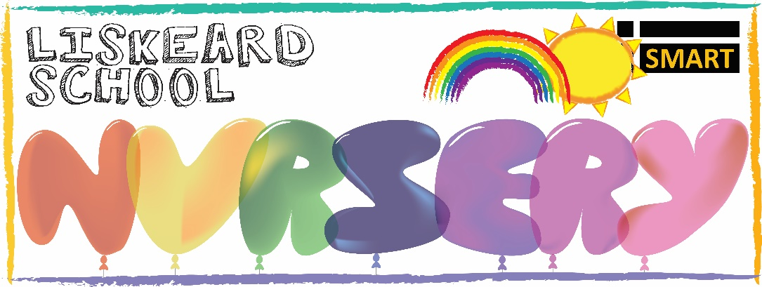

25/05/2022
Dear Parents/Carers,
This year seems to be flying by and we are scarily approaching our second half of the term which means saying goodbye to our pre-school children. We are continuing to support the children’s transitions to school, thought he following;
- Pictures of each child’s early years teachers
- Pictures of the building and classrooms
- Looking at colours and logos on our school uniforms
- Contacting your child’s chosen school to arrange a visit to the nursery
- Talking about routines during the day and the sound of bells
We have continued to look at our names, tracing over the letters and recognising how many and the pattern our names consist of. This has been supported since September to fully support your child’s transition from nursery to school and the activities that will be planned by their teachers, we continue to support our phase 1 phonics and will be looking at work towards part 6 and 7 which are voice sounds and oral blending and segmenting.
As a nursery we continue to provide the children with a range of activities each day which fully promote and support each child’s learning and development in support with their next steps. We continue to focus on our three I’s which fully support each activity that is provided to the children (Intent, Implementation and Impact), this allows us to see progression, engagement and enriched learning.
Over these past few weeks you may have been introduced to Courtney who will be working alongside Lisa in the Rainbow Room every Monday, Tuesday and Thursday. Chloe has been absent these past few weeks in the Starlight room (2-3) due to a fractured ankle, we look forward to Chloe returning Monday 6th June after half term.
A few important dates:
The nursery will be closed on Friday 15th July for the Queens Jubilee. With an additional bank holiday this year being in the half term we have to take a supplementary day out of the half term to accommodate for the day lost, therefore please do not attend nursery on that day. We are sorry for any inconvenience this causes.
Return Date for September:
The nurseries first day for return will be: Monday 5th September 2022.
Easter Egg Hunt:
Although very long awaited, the Easter hunt was a great success! The children thoroughly enjoyed searching for the eggs, face painting, dancing and crafts (Although the time seemed to fly by). With your support we raised a total of £25 which is fantastic.
Pool Part for our Pre-School Leavers:
The nursery will be holding a pool party for our Pre-School leavers only on Wednesday 20th July from 2.30pm-4.30pm, invitations will be sent out in the coming weeks, but we would appreciate putting the date in your calendar. We ask that the following;
- Please bring your child already dressed in the swimming costume
- A bag with spare clothes, towel, sun cream and sun hat
- We would appreciate your support with party food, a list will soon be available (we would be very grateful for a donation of one or two items)
Dobwalls School Nursery:
Some parents have been asking how the nursery at Dobwalls is progressing, we have had great interest in the provision and parents have had lots of positive words to say about the updated indoor environment. Each room has been freshly painted, new carpets, new resources and the team have had lots of training ready for our opening on Monday 6th June.
We are currently trying to think of names for each room (2-3 years and 3-5 years), at Liskeard as you know we have Rainbow Room 0-2, Starlight Room 2-3 and Sunshine Room 3-5. We would love to hear you suggestions on what we could name our new rooms.
Ideas:
- Caterpillars and Butterflies
- Space theme?
Learning journey’s
You will receive your child’s learning journey in July, once you have received this you will be able to keep this at home with you and another one will be started in September if you will be continuing with us.

If you have any questions, please contact me.
Kind regards
Rachel.

