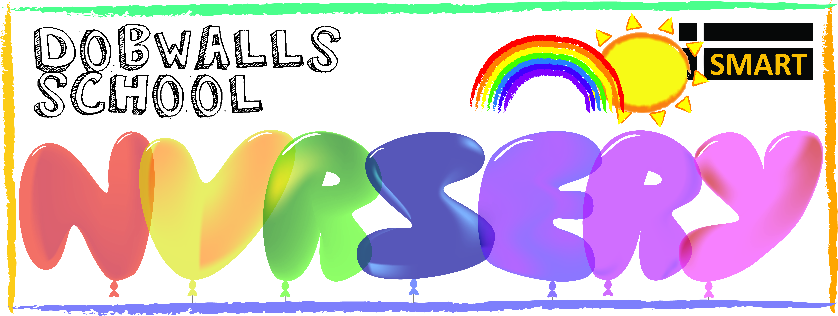

Dear Parents/Guardians,

We are pleased to announce that Dobwalls School Nursery are taking steps to implement a Sun Safe Nursery policy and teaching. The content of which forms part of our duty of care to ensure the health and wellbeing of your child/children during nursery hours.

This is a voluntary undertaking by the nursery following an invitation from Sun Safe Nurseries (an Award Scheme), which has been developed by national skin cancer charity 'Skcin', to encourage the necessary culture change regarding attitudes towards sun safety required to combat the soaring rates of skin cancer in the UK.

Whilst we recognise that some sun is good for us, we are mindful of the importance of protecting the children in our care from the dangers of over exposure to UV.

Skin cancer is now the most common and fastest rising cancer in the UK. Malignant melanoma, the deadliest form of the disease is now the most common cancer in young adults aged 15-34. Burning as a young child can cause irreparable damage to a child’s delicate skin, that over time can develop with serious consequences.

However, the good news is that skin cancer is almost entirely preventable and simple steps can be undertaken to ensure that your child’s skin is protected from the suns harmful rays.

We therefore believe that together we have a duty of care to ensure that our children grow up with sufficient knowledge of sun safety and that all children at our nursery are adequately protected against the sun’s harmful rays. As such we will be utilising the Sun Safe Nurseries Scheme to teach children in our care basic sun safe messages through engaging teaching resources.

In addition, whilst we have always strongly encouraged parents to send their child/children to nursery with sunscreen and a hat to use during outdoor play in the hotter months, we understand parents sometimes forget. As part of gaining our Sun Safe Nursery Status we are committed to ensuring that all parents/guardians are further informed and reminded of the importance of sending your child into nursery with an appropriate sun hat and quality sunscreen.

Sun hats should be either broad-brimmed or legionnaire style (to shade the face, neck and ears that can easily burn) and
sunscreen should offer broad spectrum UVA/UVB protection with a minimum 4 star rating and Sun Protection Factor 30+.
(Please label each item with your child’s name to ensure its safe return).

As part of our commitment to providing a sun safe environment we also recognise that role models have a key part to play in influencing children’s behaviour in regard to sun protection practices. It is therefore important that our staff as well as parents and/or guardians are seen to be actively adopting the same sun safe practices. We have therefore also supplied each parent/guardian with a ‘Sun Safety Fact Sheet’ provided by the national skin cancer charity Skcin, for you to read and retain.

We hope you understand our concern for the health and wellbeing of your child/children and therefore ask that you kindly fill in the slip below and return it to the nursery office in recognition of our correspondence.

For further information about skin cancer, its prevention, sun safety and the charity ‘Skcin’, please visit www.skcin.org

Yours Sincerely,

SMART Nursery Manager

Sun Safe Nurseries Parent/Guardian Reply Slip:

…………………………………………………………………………………………………………….………………………………………………………………………………

I can confirm that I have read the letter regarding Sun Safe Nurseries and understand the importance of sending my child/children to nursery with an appropriate hat and quality sunscreen to help protect my child from over-exposure to UV during outdoor play in nursery hours.

Signed………………………………………………………………………………………………………………………Date:…………………………………………………

Print Name:………………………………………………………………………………………………………………………………………………………………………….

Parent/Guardian of Child/Children’s Name(s) …………………… ……………………………………………………………………………………………….

